

.O_que_podemos_fazer_por_você {

font-size: 46px;

font-family: "Bw Helder DEMO";

color: rgb(255, 255, 255);

font-weight: bold;

line-height: 1.2;

text-align: center;

text-shadow: 0px 3px 0px rgba(0, 0, 0, 0.37);

-moz-transform: matrix( 4.87074796557079,0,0,4.85418103485278,0,0);

-webkit-transform: matrix( 4.87074796557079,0,0,4.85418103485278,0,0);

-ms-transform: matrix( 4.87074796557079,0,0,4.85418103485278,0,0);

position: absolute;

left: 735.768px;

top: 206.779px;

z-index: 130;

}



.Serviços_Estratégicos {

font-size: 28px;

font-family: "Bw Helder DEMO";

color: rgb(255, 255, 255);

font-weight: bold;

line-height: 1.2;

text-align: center;

-moz-transform: matrix( 4.87074796557079,0,0,4.85418103485278,0,0);

-webkit-transform: matrix( 4.87074796557079,0,0,4.85418103485278,0,0);

-ms-transform: matrix( 4.87074796557079,0,0,4.85418103485278,0,0);

position: absolute;

left: 770.749px;

top: 335.887px;

z-index: 125;

}



.Diagnóstico_Organizacional {

font-size: 12px;

font-family: "Bw Helder DEMO";

color: rgb(255, 254, 254);

font-weight: bold;

line-height: 1.2;

text-align: left;

-moz-transform: matrix( 2.36875534599017,0,0,2.36633716989821,0,0);

-webkit-transform: matrix( 2.36875534599017,0,0,2.36633716989821,0,0);

-ms-transform: matrix( 2.36875534599017,0,0,2.36633716989821,0,0);

position: absolute;

left: 648.274px;

top: 452.487px;

z-index: 99;

}

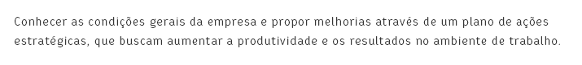

.Conhecer_as_condições_gerais_da_empresa_e_propo {

font-size: 14px;

font-family: "Bw Helder DEMO";

color: rgb(54, 54, 54);

line-height: 1.714;

text-align: left;

-moz-transform: matrix( 0.99993191099272,0,0,0.99999998757428,0,0);

-webkit-transform: matrix( 0.99993191099272,0,0,0.99999998757428,0,0);

-ms-transform: matrix( 0.99993191099272,0,0,0.99999998757428,0,0);

position: absolute;

left: 548.326px;

top: 571.779px;

width: 669.223px;

height: 38.125px;

z-index: 97;

}



.Saiba_mais {

font-size: 14px;

font-family: "Open Sans";

color: rgb(21, 180, 188);

text-transform: uppercase;

line-height: 1.429;

text-align: left;

-moz-transform: matrix( 1.00069747667823,0,0,1,0,0);

-webkit-transform: matrix( 1.00069747667823,0,0,1,0,0);

-ms-transform: matrix( 1.00069747667823,0,0,1,0,0);

position: absolute;

left: 549.123px;

top: 618.997px;

z-index: 95;

}



.Atendimento_Individual {

font-size: 24px;

font-family: "Bw Helder DEMO";

color: rgb(54, 54, 54);

font-weight: bold;

line-height: 1.2;

text-align: left;

-moz-transform: matrix( 7.50288050589816,0,0,7.50288050589815,0,0);

-webkit-transform: matrix( 7.50288050589816,0,0,7.50288050589815,0,0);

-ms-transform: matrix( 7.50288050589816,0,0,7.50288050589815,0,0);

position: absolute;

left: 405.418px;

top: 1789.725px;

z-index: 44;

}



.Diagnóstico_Empresarial {

font-size: 16px;

font-family: "Bw Helder DEMO";

color: rgb(54, 54, 54);

font-weight: bold;

line-height: 1.25;

text-align: center;

-moz-transform: matrix( 0.99993192695998,0,0,1,0,0);

-webkit-transform: matrix( 0.99993192695998,0,0,1,0,0);

-ms-transform: matrix( 0.99993192695998,0,0,1,0,0);

position: absolute;

left: 322.98px;

top: 1260.032px;

z-index: 115;

}



.Crie_a_mudança_que_sua_empresa_precisa {

font-size: 28px;

font-family: "Bw Helder DEMO";

color: rgb(255, 255, 255);

font-weight: bold;

line-height: 1.69;

text-align: right;

-moz-transform: matrix( 2.36886790491019,0,0,2.36633716989821,0,0);

-webkit-transform: matrix( 2.36886790491019,0,0,2.36633716989821,0,0);

-ms-transform: matrix( 2.36886790491019,0,0,2.36633716989821,0,0);

position: absolute;

left: 505.702px;

top: 2337.652px;

z-index: 34;

}

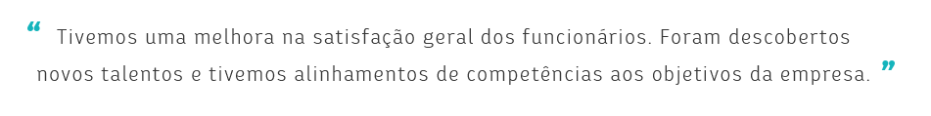

.Tivemos_uma_melhora_na_satisfação_geral_dos_fun {

font-size: 20px;

font-family: "Bw Helder DEMO";

color: rgb(54, 54, 54);

line-height: 1.875;

text-align: center;

-moz-transform: matrix( 1.5621188941395,0,0,1.5621188941395,0,0);

-webkit-transform: matrix( 1.5621188941395,0,0,1.5621188941395,0,0);

-ms-transform: matrix( 1.5621188941395,0,0,1.5621188941395,0,0);

position: absolute;

left: 526.874px;

top: 2388.222px;

z-index: 82;

}